**Concise Practical parasitology**

**PART ONE**

**"Protozoa”**

**Mosab Nouraldein Mohammed**

**Head of parasitology department**

**Faculty of Medical Laboratory Sciences**

**Elrazi University Sudan**

**Dedication:**

***To my***

***Mother (Madina A. Mohammed)***

***The gift of the god to me***

**1**

**Acknowledgement:**

**In this book we try to simplify the parasitological material to the undergraduate students and to those who wants to know general ideas about parasitology.**

**Mosab, January 2016**

**2**

***Contents*:**

***Over view ……………………………………………………………***

***Entamoeba histolytica………………………………………………***

***Giardia lamblia …………………………………………………….***

***Trichomonas vaginalis……………………………………………..***

***Blantidium coli …………………………………………………….***

***Toxoplasma gondii ………………………………………………..***

***African trypanosomiasis ………………………………………….***

***American trypanosomiasis ……………………………………….***

***Leishmaniasis ………………………………………………………***

***Malaria ……………………………………………………………..***

***Isospora belli ………………………………………………………***

***Cryptosporidium parvum………………………………………..***

***Preservation of stool specimen ………………………………….***

***Parasitogical terms………………………………………………***

***Instruments* ……………………………………………………..**

**Overview**

***Specimens are collected according to:***

**Patient complains.**

**Type of the required test**

**Habitat of the parasite**

**Laboratory personnel should deal with all specimens inside the as infectious.**

**Specimens should be collected in appropriate containers**

***Stool specimens:***

**Should be collected in:**

**Clean**

**Dry**

**Wide mouthed without neck**

**Free from disinfectants**

**3**

***Urine specimens :***

**It should be collected in :**

**Sterile container**

**Transparent**

**Urine specimens required for diagnosing urinary schistosomiasis should be collected after the following advices to the patient :**

**specimens from urine voided at the mid day are preferable.**

**Excersie is required to enhance the sensitivity of the test .**

**4**

***Blood specimens :***

**Blood specimens are collected either from capillaries or veins .**

**Blood specimens must be collected at specific times when diagnosing certain parasites such as in filariasis (due to the periodicity of microfilaria ) .**

**Suitable anticoagulant must be used ( trisodium citrate for microfilaria , EDTA for plasmodium and trypanosomes parasites )**

***Macroscopic examination :***

**Physical examination done by naked eye without magnifying tools .**

**Normally Stool color is brown and the normal PH is alkaline and the consistency is semi formed without mucus or blood or worm segment , Urine specimens normally are amber (yellow) and the PH of the normal urine is acidic .**

**Stool odor are affected by the diet and the color of urine can be changed by diet and certain drugs and vitamins .**

**4**



***Microscopic examination :***

**We use light microscope with magnifying lenses (x10, x40,x100) .**

**X10 is known as low power field objective lens**

**X40 is known as high power field objective lens**

**X100 is known as oil immersion lens because we add oil drop to the stained smear (oil will increase the refractive index ) .**

**Firstly we use x10 to adjust the field and to search for helminthes ova (egg) or larvae ,then use x40 to identify the parasite and to detect intestinal protozoa cyst and trophozoite .**

**5**

**Normal structure in stool specimen**

**6**

***Entamoeba histolytica :***

**Cause amoebic dysentery .**

**Dysentery means blood and mucous are present in feces.**

**It has direct life cycle.**

**Habitat : large intestine**

**Diagnostic stages :trophozoite and cyst**

***Diagnostic methods :***

**Wet mount (wet preparation) .**

**Permanent staining (e.g. trichrome stain) .**

**Concentration techniques**

**Culture in certain culture media such as NNN medium .**

**CAP (cellulose acetate precipitin ) test for extra intestinal amoebiasis .**

**Molecular techniques (PCR: polymerase chain reaction)**

**Also in cases of extra intestinal (invasive ) amoebiasis we can use radiological methods and aspiration from organ suspected to be containing amoebic mass to detect the trophozite .**

**In case of amoebic dysentery the PH of stool specimen is acidic**

**7**

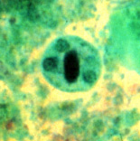

**Entamoeba histolytica cyst**

|  |  |
| --- | --- |
| **Entamoeba coli** | **Entamoeba histolyica** |
| **Cyst are larger in size** | **Cyst are smaller in size** |
| **Has clear cytoplasm** | **Has granular cystoplasm** |
| **Mature cyst posses 8 nuclei** | **Mature cyst posses 4nuclei** |
| **Trophozoite contain bacteria** | **Trophozoite contain RBCs** |
| **Nucleus of trophozoite with peripheral karyosome** | **Nucleus of trophozoite with central karyosome** |
| **Non pathogenic amoeba** | **Pathogenic amoeba** |
| **Alkaline PH** | **Acidic PH (amoebic dysentery)** |

**8**

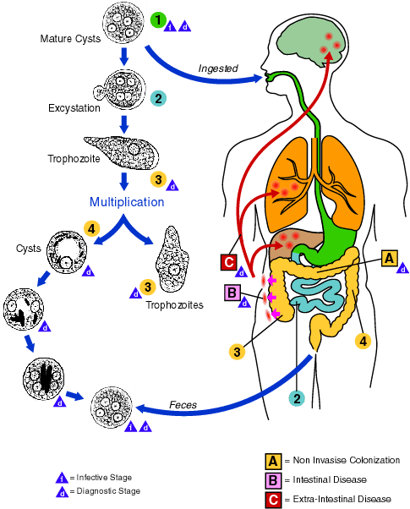

**Life cycle of Entamoeba histolytica**

**9**

***Giardia lamblia***

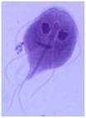

**It is an intestinal flagellate**

**Specimen is bulky offensive and pale colored .**

**Habitat : upper part of small intestine (duodenum and jejunum ).**

**It has direct life cycle**

**Specimens: stool , duodenal aspirate or blood for serology .**

***Laboratory diagnostic methods :***

**Wet mount (wet preparation )**

**Permanent staining methods (e.g. trichrome stain )**

**Concentration techniques .**

**Culture in certain culture media such as NNN culture medium .**

**Entro capsule test ( string test ) to detect trophozoite .**

**Immunological (serological) test such as ELISA (enzyme linked immunosorbent assay ) .**

**Molecular techniques (e.g. PCR) .**

**10**

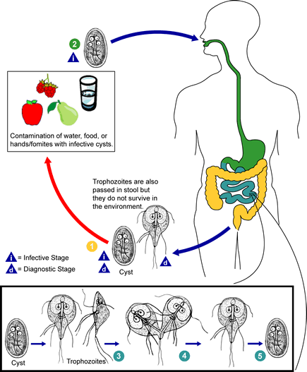

**11**

***Trichomonas vaginalis***

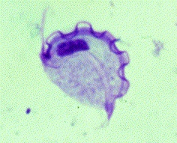

**It is a urogenital flagellate**

**Causes sexually transmitted disease known as trichomonasis .**

**Habitat :vagina ,urethra ,prostatic gland**

**It has direct life cycle and posses only trophozoite stage .**

**Specimens : vaginal discharge ,urethral discharge , prostatic fluid ,urine or semen .**

***Laboratory diagnosis methods :***

**Wet preparation for specimens directly or after sedimentation by centrifugation .**

**Culture in certain culture media such as Diamond culture medium .**

**Serological test (OSOM test ):**

**Principle of the test :**

**The OSOM® Trichomonas Rapid Test uses color immunochromatographic, capillary fl ow, “dipstick”**

**technology. The test procedure requires the solubilization of Trichomonas proteins from a vaginal swab 11**

**by mixing the swab in Sample Buffer. The OSOM® Trichomonas Rapid Test Stick is then placed in the**

**sample mixture and the mixture migrates along the membrane surface. If Trichomonas is present in**

**the sample, it will form a complex with the primary anti-Trichomonas antibody conjugated to colored**

**particles (blue). The complex will then be bound by a second anti-Trichomonas antibody coated on the**

**nitrocellulose membrane. The appearance of a visible blue test line along with the red control line will**

**indicate a positive result**

**Molecular techniques ( e.g. PCR) .**

**12**

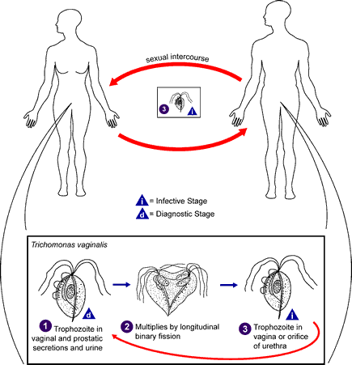

**13**

***Blantidium coli :***

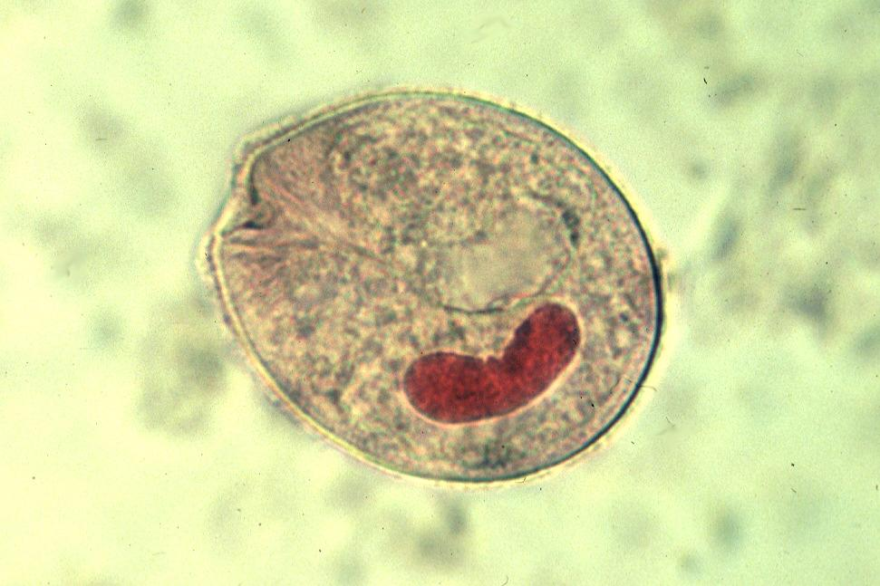

**It is an intestinal ciliate**

**It is the largest intestinal protozoan parasite**

**Habitat : large intestine**

**It has direct life cycle, pigs are the definitive host .**

**Specimen : stool ,dysenteric stool may contain trophozoite.**

***Laboratory diagnosis methods :***

**Wet mount (wet preparation )**

**Permanent staining techniques ( e.g. trichrome stain ).**

**Concentration techniques .**

**Molecular technique ( e.g. PCR) .**

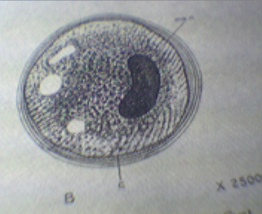

**Cyst stage**

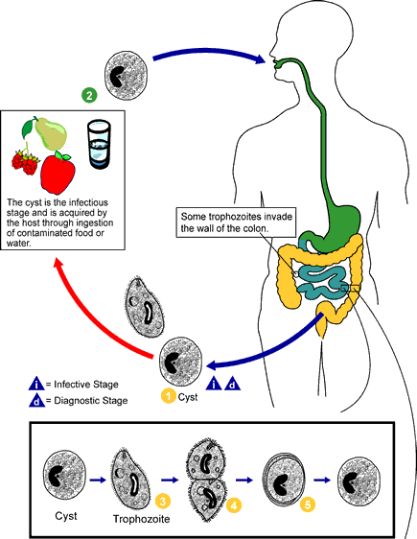

**Life cycle of Blantidium coli**

***Toxoplasma gondii***

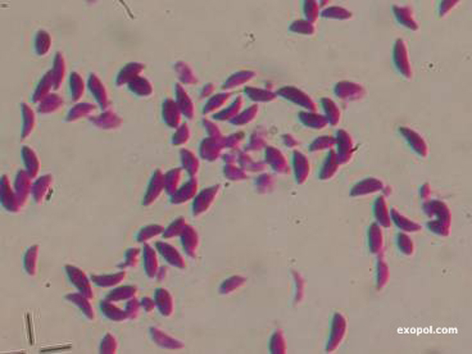

**Obligate intracellular coccidian parasite**

**Definitive host: cat**

**Specimens: lymph node aspirate**

**Bone marrow aspirate**

**Body fluids**

**Biopsies**

***Laboratory diagnosis :***

**Sabin field man dye test**

**Immunochromtographic test**

**Frankel test ( intradermal method) .**

**Enzyme linked immunosorbent assay (ELISA)**

**Indirect haemagglutination test**

**Indirect immuno fluorescent antibody test**

**Animal inoculation tests**

**Molecular techniques (PCR) .**

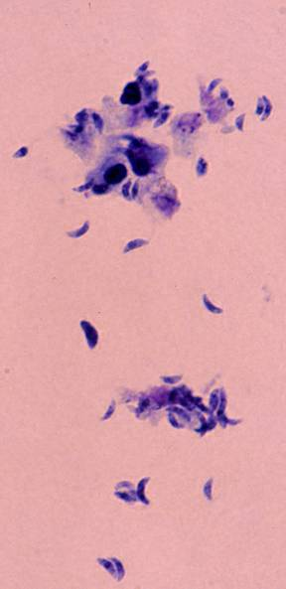

**Tachyzoite**

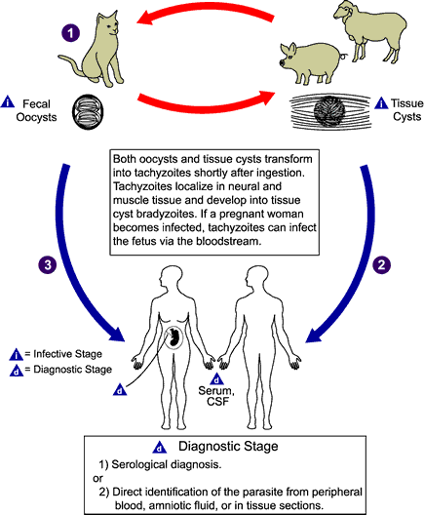**life cycle of toxoplasma gondii**

***African trypanosomiasis (sleeping sickness)***

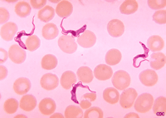

**It is a vector bornedisease(tse tse fly of the genus Glossina) caused by hemoflagellate parasite T.brucei rohedisciense and T.brucie gambiense.**

**Has an indirect life cycle .**

***Laboratory diagnosis:***

**Specimens : lymph node aspirate , skin aspirate (chancre) , CSF (cerebrospinal fluid) , blood.**

**Detection of trypanosome in stained smear from lymph node or skin chancre .**

**Detection of trypanosome in CSF .**

**ELISA (Enzyme Linked Immunosorbent assay ) .**

**IFAT (Indirect Immunefluorescent Antibody Test ) .**

**Culture in NNN medium .**

**Molecular techniques (PCR) .**

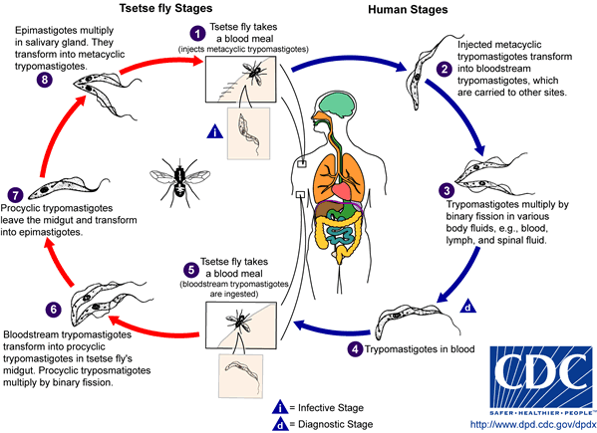**Life cycle of African trypanosome**

***American trypanosomiasis ( Chagas disease )***

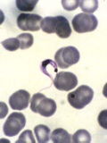

**Vector borne disease ( Reduviid Tritomaniae bug ) caused by trypanosome Cruzi**

***Laboratory diagnosis :***

**Detection of the trypanosome in:**

**Blood film ( thick or thin )**

**Buffy coat concentration technique**

**Immunological techniques (serology) :**

**ELISA (Enzyme Linked Immuno Sorbent Assay ) .**

**IFAT (Indirect Immuno Fluorescent Antibody Test ) .**

**Molecular techniques (PCR) .**

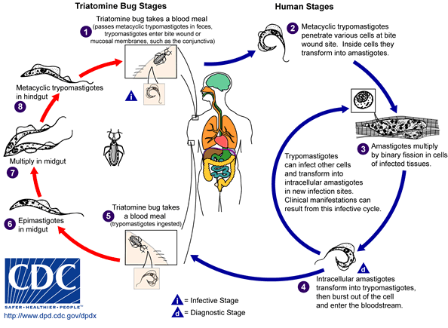

**Life cycle of American trypanosome**

***Leishmaniasis***

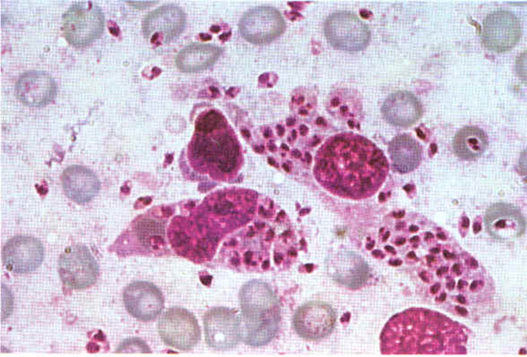

**Vector borne (sand fly of the genus Phelebotomus" old world " and Lutzomyia" new world" ) zoonotic disease caused by hemoflagellate parasite of leishmania species .**

**Indirect life cycle between invertebrate vector and vertebrate animal and human .**

***Cutaneous leishmaniasis:***

***Laboratory diagnosis :***

**Examining giemsa stained smear from ulcer ( specimen taken by scraping the edge of ulcer, impression or from biopsy) .**

**Leishmanin Skin Test (LST) "Montenegro test)".**

**Culture in NNN mediumand RPMI1640(Roswell Park Memorial institute ) .**

***Visceral Leishmaniasis :***

**Vector borne disease affect the visceral organ ( reticuloendothelial system ) .**

***Laboratory diagnosis :***

**Specimens : lymph node aspirate , bone marrow aspirate , splenic aspirate ( avoided in pancytopenic patients ) and blood for serology .**

**Examining giemsa stained smear of lymph node , bone marrow or splenic aspirate( more sensitive 94%) .**

**DAT (Direct Agglutination Test ) .**

**IFAT (Indirect Fluorescent Antibody Test ).**

**KATEX test .**

**Rk39 test**

**ELISA (Enzyme Linked Immuno Sorbent Assay ) .**

**Formal gel test .**

**Culture in NNN medium or in RPMI1648(Roswell Park Memorial institute ) . .**

**Molecular techniques ( PCR ) .**

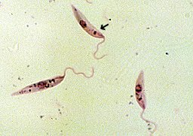

**Promastigote**

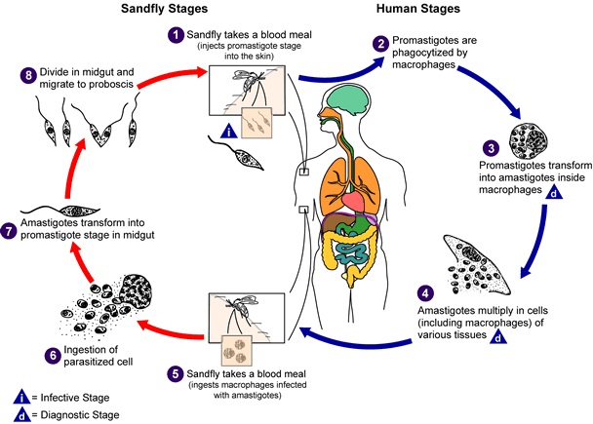

**Life cycle of leishmania species**

***Malaria***

**Vector borne ( female of Anopheles mosquito ) disease caused by plasmodium species ( Falciprum , Vivax Malariae and Ovale ) .**

**Indirect life cycle between invertebrate vector and humans .**

***Laboratory diagnosis :***

**Specimen : blood .**

**Examining of thick and thin giemsa stained blood films.**

**Buffy coat concentration technique**

**Immuno chromatographic test (Rapid Diagnostic Tests).**

**ELISA (Enzyme Linked Immuno Sorbent Assay ).**

**IFAT (Indirect Fluorescent Antibody Test ).**

**Culture in RPMI 1648((Roswell Park Memorial institute).**

**Molecular techniques (PCR) .**

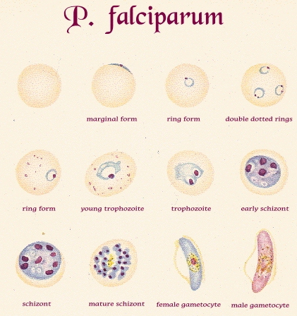

**Plasmodium falciprum**

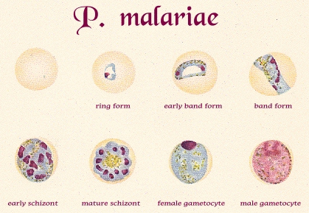

**Plasmodium malariae**

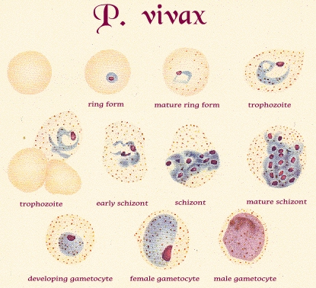

**Plasmodium vivax**

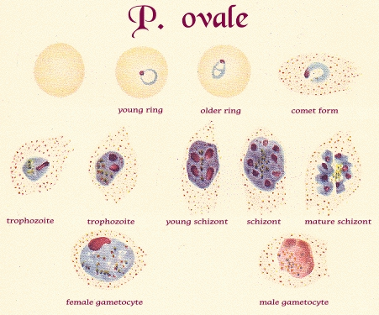

**Plasmodium ovale**

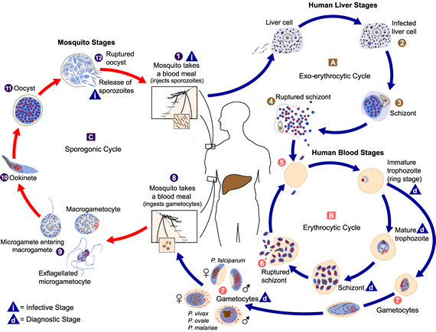**life cycle of malaria parasite**

***Isosopra belli***

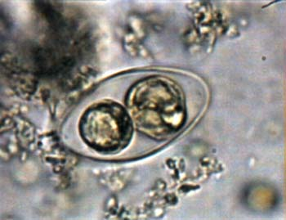

**Intestinal coccidian parasite .**

**Direct life cycle .**

***Laboratory diagnosis :***

**Specimen : stool**

**Finding oocyst in feces .**

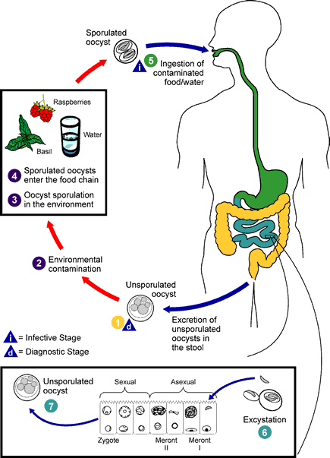

***Cryptosporidium parvum***

**Intestinal coccidian parasite causes zoonotic disease cryptosporidiosis in humans and animals .**

***Laboratory diagnosis :***

**Specimen : stool ( watery diarrhea) .**

**Examining fecal smear stained with modified ZN stain .**

**ELISA (Enzyme Linked Immuno Sorbent Assay ) .**

**Molecular techniques ( PCR) .**

.

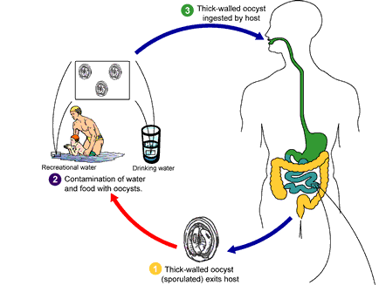

**Life cycle of cryptosporidium parvum**

***Preservation of stool specimens***

|  |  |  |  |  |
| --- | --- | --- | --- | --- |
| **MIF** | **SAF** | **PVA** | **Formalin 4%** | **Character** |
| **+/-** | **+/-** | **+++** | **+/-** | **Toxicity** |
| **Limited** | **Long** | **Long** | **Long** | **Shelf life** |
| **Easy** | **Easy** | **Difficult** | **Easy** | **Preparation** |
| **Egg++**  **Cyst ++**  **Troph +/-** | **Egg++**  **Cyst ++**  **Troph: +++** | **Egg++**  **Cyst +++**  **Troph: +++** | **Egg++**  **Cyst ++**  **Troph +/-** | **Quality of preservation** |
| **Possible** | **Possible** | **Not possible** | **Possible** | **Formal ether concentration technique** |
| **Not possible** | **mod. Z N** | **Only Trichrome** | **Not possible** | **Permanent stained smear** |

***Parasitological terms***

***Life cycle :***

**cycle of development of parasite from definitive host and back to the definitive host .**

***Direct life cycle:***

**Require only one host (definitive host) .**

***Indirect life cycle :***

**Require two or more hosts .**

***Definitive host ( Final host) :***

**is a host lodging the sexual , mature or adult stages of the parasite .**

***Intermediate host :***

**Is a host lodging the asexually reproducing or immature stages of the parasite .**

***Transitory , Accidental, paratenic host :***

**Is a host lodging parasitic stages without further reproduction .**

***Ectoparasite:***

**Is a parasitic organism that lives on the outer surface of it is host e.g. lice and ticks .**

***Endoparasite :***

**Is a parasite that lives inside the body of their host e.g. Entamoeba histolytica .**

***Obligate parasite:***

**This parasite is completely dependent on the host during a part or all of it is life cycle ,e.g. Plasmodium species.**

***Facultative parasite :***

**Is an organism that exhibits both parasitic and non- parasitic modes of living e.g. Naegleria fowleri .**

***Erratic parasite:***

**Is a parasite that wanders in to organ in which it is not usually found e.g. Entamoeba histolytica in the liver .**

***Trophozoite :***

**The active or feeding stage of a single- celled organism**

***Cyst* :**

A cyst may be the resistant dormant stage of a single celled organism which passed out and encourages the propagation of species .Alternatively , cyst may refer to the intermediate stage of some tapeworm (e.g. ,hydatid cyst).

***Host* :**

**The organism in which a parasite lives .**

***Hermaphrodite :***

**A species in which one organism contains both sets of sex organs .**

***Helminth (worm) :***

**A multicellular organism which is generally longer than it is wide or deep.**

***Zoonosis :***

**An infection of a human by an organism which is usually parasitic in animal .**

***Vector* :**

**An organism (usually insect) which transmits a parasitic organism from one host to another .**

***Mechanical vector :***

**Merely carry the organism from one place to another .**

***Biological vector :***

**It forms a necessary part of the life cycle .**

***Protozoa* :**

**Is the single –celled organism**

**Pathogen :**

**Any organism which causes harm to its host .**

***Parthogenesis* :**

**A process which may occur in some sexually reproducing animals where offspring are produced without fertilization .**

***Opportunistic pathogen :***

An organism which is normally harmless (commensal ) , but which may turn nasty if given the opportunity .

***Larva*:**

An immature stage of an organism which bears no structural resemblance to the mature stage .

***Geohelminth :***

A worm which spends a certain time during its life cycle living in the soil .

***Dysentery :***

Diarrhea with associated blood and mucus .

***Dioecious*:**

Having two sex (opposed to hermaphrodite ) .

***Diarrhea* :**

Frequency of bowel movement or stool ,often associated with loose consistency .

***Symbiosis* :**

"living together "; any two organisms living in close association ,commonly one living in or on the body of the other .

***Parasitism :***

A relationship of two organism ,which the smaller organism (parasite) has the potential of harming the larger (host) and in which the parasite relies on the host for nutrients and place to live .

***Commensalism :***

One benefits and the other is neither helped nor harmed .

***Mutualism :***

The two organisms are mutually interdependent .

***Phoresis* :**

Organisms are "travelling together" without any physiological or biochemical dependence .

***Host specificity :***

Most parasites develop only a restricted range of host species .

***Prepatent period :***

The time between infection with parasite and when the parasite can be detected in the host via diagnostic method .

***Incubation period :***

The time between the initiation of infection and onset of disease .

***Infective stage :***

Stage of the parasite that can initiate anew infection within within another host .

***Fomite :***

**An inanimate object that can transmit pathogens from one host to another .**

***Route of migration :***

**Routes via which the parasite migrates the host .**

***Route of infection :***

**Way in which the parasite enters the host .**

***Endemic /enzootic:***

**A disease which is present in an area and is expected to be there at stable rate .**

***Epidemic /epizootic:***

**The presence of a disease at a level higher than what is normally expected .**

***Prevalence* :**

**Number of hosts infected divided by the number of hosts examined at a point in time.**

***Incidence :***

**Number of new cases of infection or disease /unit of time .**

***Overdispersion :***

**A situation where relatively few hosts harbor the majority of all parasites in a population .**

***Underdispersion :***

**All hosts have same number of parasites .**

**Techniques**

**Enzyme linked immunosorbent assay :**

**Antibodies will bind to very specific antigens to formantigen-antibody complexes and enzyme –linked antigens or antibodies can be used to detect and measure these complexes**

**Western blot:**

**This an immunoassay test method that detects specific proteins in blood or tissue .It combines an electrophoresis step with a step that transfers (blots) the separated proteins onto a membrane .**

**Polymerase chain reaction :**

**It’s a laboratory method used for making a very large number of copies of short sections of DNA from a very small sample of genetic material .**

**Fluorescent in stu hybridization :**

**This molecular testing method uses fluorescent probes to evaluate genes and or /DNA sequences on chromosomes .**

**Wet mount :**

**It’s a process in which a glass slide holding a specimen suspended in a drop of liquid for microscopic examination .**

**Microscope slide :**

**A small flat rectangular piece of glass on which specimens can be mounted for microscopic study .**

**Cover glass "cover slip " :**

**A small and very thin piece of glass used to cover the specimen on a microscope slide .**

**Formalin –ether sedimentation concentration technique :**

**A sedimentation method to separate parasitic elements from fecal debris through centrifugation and the use of ether to trap debris in a separate layer from the parasites .**

***Instruments***

**Light microscope : (magnifying equipment )**

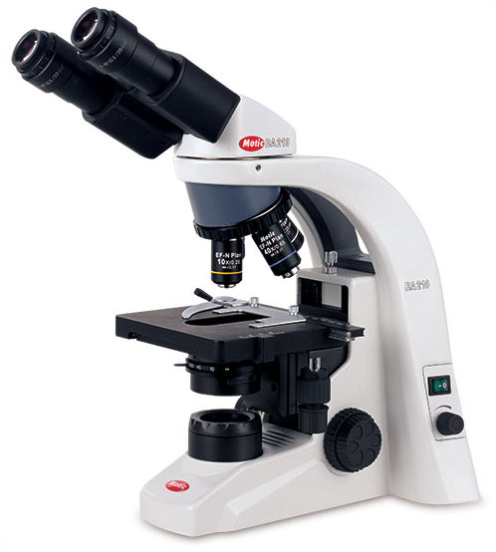

**Centrifuge : ( to separate particles )**

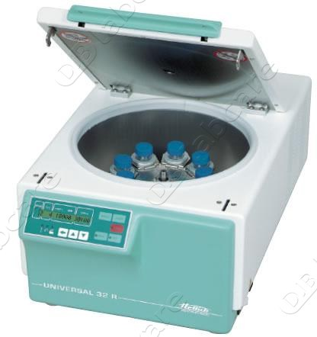

**ELISA reader :( immunological technique)**

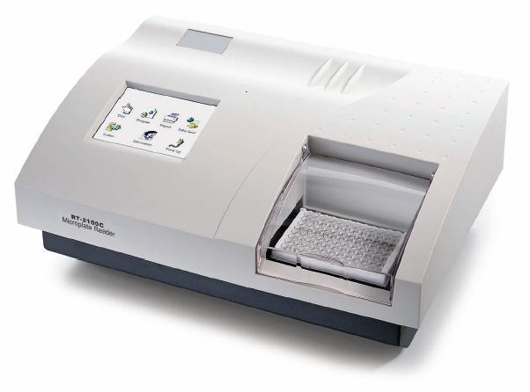

**Thermal cycler : (molecular technique )**

